**Weekly report 8**

**Group 14: Learners.**

**Heart Disease Prediction.**

**08-04-23**

Members:

1. Varun Parekh - AU2040011
2. Vanshit Shah - AU2040098
3. Madhvendra Jhala - AU2040162
4. Ushmay Patel - AU2040253

Script: <https://colab.research.google.com/drive/168A9sTkOyReA8gy1ugn8eCP12Xjg55lZ?usp=sharing>

We are working on feature importances as sir suggested.

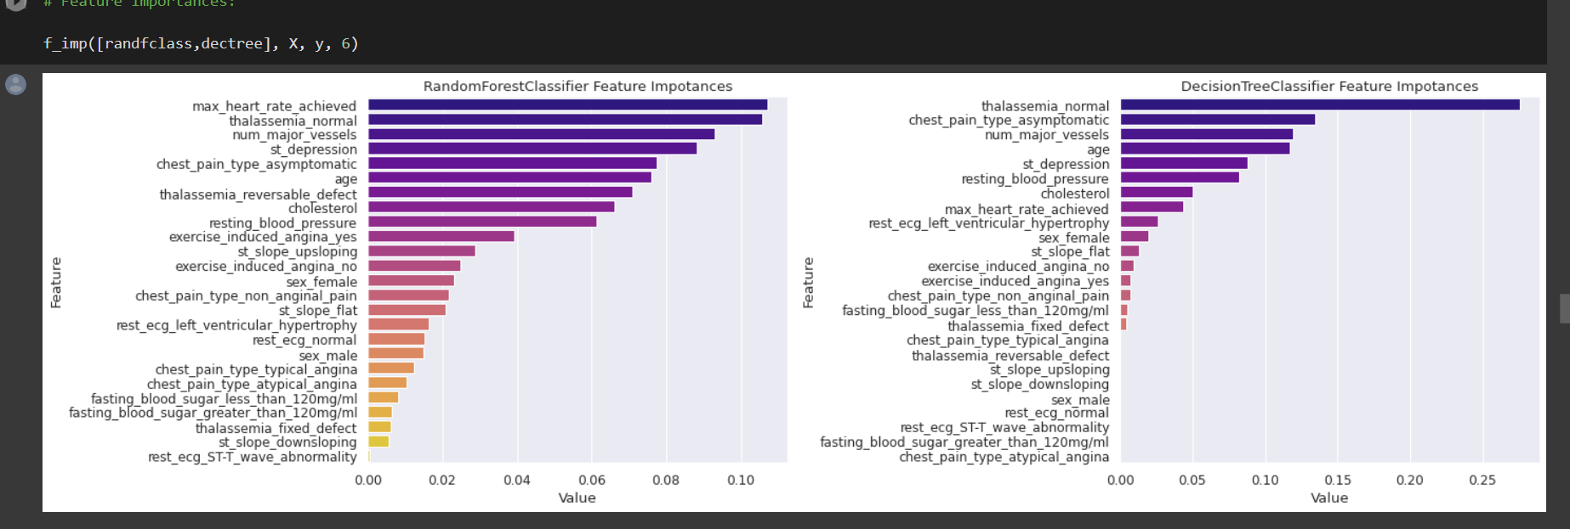

We are learning different curves that show us how the experience increases as their training set size varies.

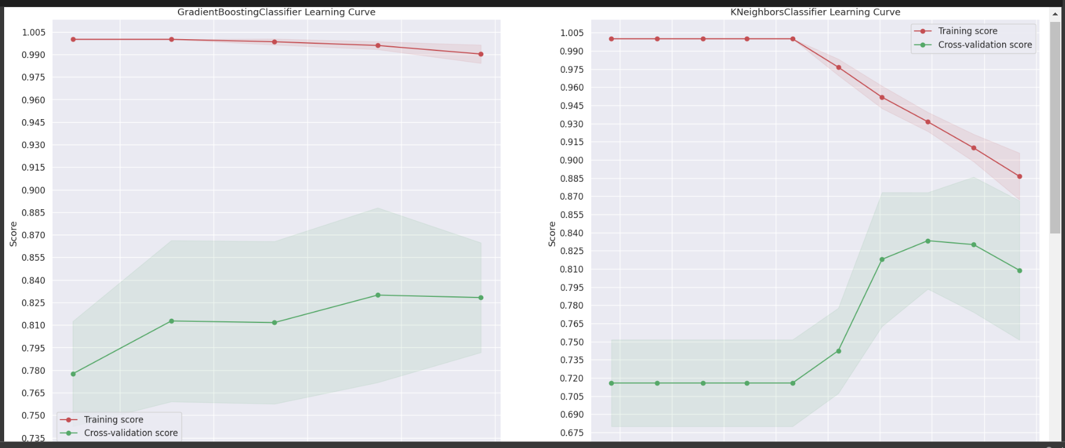

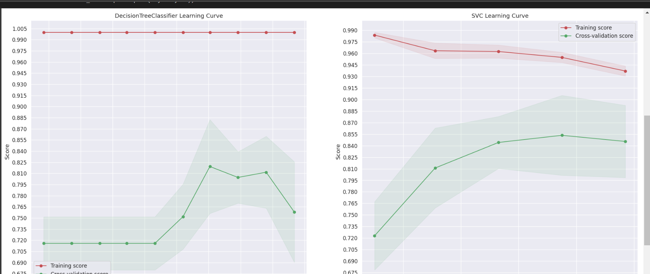

This is the correlation matrix which helps us to find the best parameters as we remove all the highly correlated features so as to get a better prediction with fewer features.

